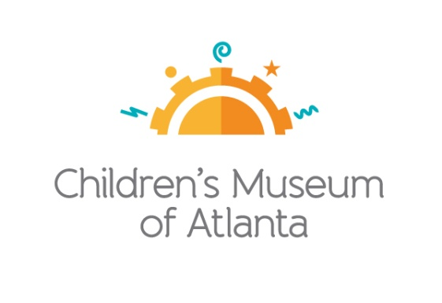

CONTACT
Alison Wentley
BRAVE Public Relations
404.233.3993
awentley@emailbrave.com

*MEDIA ADVISORY*
Family Free Day returns to Children’s Museum of Atlanta on August 21
PNC Foundation, The Coca-Cola Foundation and CareSource fund arts and music-themed day of learning

ATLANTA (July 26, 2019) –Families are invited to visit Children’s Museum of Atlanta free of charge during Family Free Day on Wednesday, August 21. With programming specifically centered around arts and music, kids will have the opportunity to draw with chalk in the Art Studio, learn about the science of color at the Science Bar, make xylophones in the Build It Lab and more. Made possible by the support of the PNC Foundation, The Coca-Cola Foundation and CareSource, the three sessions will also offer the chance for kids to explore the Museum’s six permanent, interactive exhibits as well as Doc McStuffins: The Exhibit, which runs through September 8, 2019.

To guarantee entrance, families must pre-register online, beginning at 7 a.m. on Tuesday, August 20 for Session One, Two or Three. Families may not register for multiple sessions.

WHAT: Family Free Days
Georgia families are invited to experience an arts and music-themed admission-free visit to the only education venue of its kind in Atlanta

WHEN: Wednesday, August 21
Session One: 10 a.m.-12:30 p.m.
Session Two: 1-3:30 p.m.
Session Three: 4-6:30 p.m.

WHERE: Children’s Museum of Atlanta
275 Centennial Olympic Park Drive, NW
Atlanta, GA 30313

HOW: For more information or to register, visit childrensmuseumatlanta.org/familyfreeday.

For more information or to support Children's Museum of Atlanta, visit childrensmuseumatlanta.org
or call 404.659.KIDS [5437]

###

